Steps Content Back Tracking
Create IP entries of Content (N)for Routers along each path (i)
For each path i
Store Arrival Time $t_{i}^{arr}$
Calculate Forward Delay of path i
$$d_{i}^{fwd}=t_{i}^{arr}-t_{Consumer}^{send}$$
Build the path Performance Table
Forward Delay Estimation
Expected $\overline{RTT}≈2 d_{i}^{fwd}$
Goodput (Capacity estimate) for path i (bytes/sec): $\overline{b_{i}}=\left(1-c\right)\overline{b_{i}}+c.g_{i}$
$g_{i}=\frac{S}{r}$
S= chunk size
r_{i} =arrival delay
c =smoothing factor controlling memory vs. responsiveness (0-1)
$g_{i}$ instantaneous throughput sample from the latest chunk.

Split Content (N) into K chunks
$$N=\left\{n_{1},n_{2},…………,n_{k}\right\}$$

Create Subset $C_{i}⊂\left\{1,….K\right\}$
Multiple available path $i∈\{1,…m\}$
$$\left|C_{i}\right|=\left\lfloor \frac{w_{i}}{\sum_{j=1}^{m}{w_{j}}}.K\right\rfloor$$
$w_{i}=\frac{1}{d_{i}^{fwd}}$ or $w_{i}=\frac{\overline{b_{i}}}{r_{i}}$

Transmit chunks: $\{n_{k}:k∈C_{i}\}$for path i
Check for PIT entries
Store Chunks at CS

Consumer receives the Chunks from multiple paths $R=\bigcup_{i}{C_{i}}$

Algorithm: TrackBack
1) | Broadcast IP for content N over several paths
2) | Received IP at Producer
3) | Create Arrival Time Table  Set T  If ($t^{arr}≤T$)  $${Count}^{IP}\left(T,N\right)= \sum{1}$$
4) | $i= {Count}^{IP}$ (Number of paths)  While ($i≠0$)  Store $t_{i}^{arr}$
5) | Calculate  $$d_{i}^{fwd}=t_{i}^{arr}-t_{Consumer}^{send}$$
6) | Arrange in ascending order $d_{i}^{fwd}$  End while
7) | Fetch Corresponding Content N
8) | Split Content (N) into K chunks  $$N=\left\{n_{1},n_{2},…………,n_{k}\right\}$$
9) | Create unique Subset $C_{i}⊂\left\{1,….K\right\}$ for each path i
10) | If( $d_{i}^{fwd}< {RTT}_{CR}$)
11) | For each CR_{n} of path i from j to n
12) | Check Content Chunk $C_{nk}$ in CS
13) | if (chunk is found)  No update of CS
14) | Else  Store the Chunk C_{nk} in CS
15) | Check Next Hop Trace entry in CR_{n}
16) | Repeat Steps 13-15
17) | Consumer receives the Chunks from multiple paths $R=\bigcup_{i}{C_{i}}$

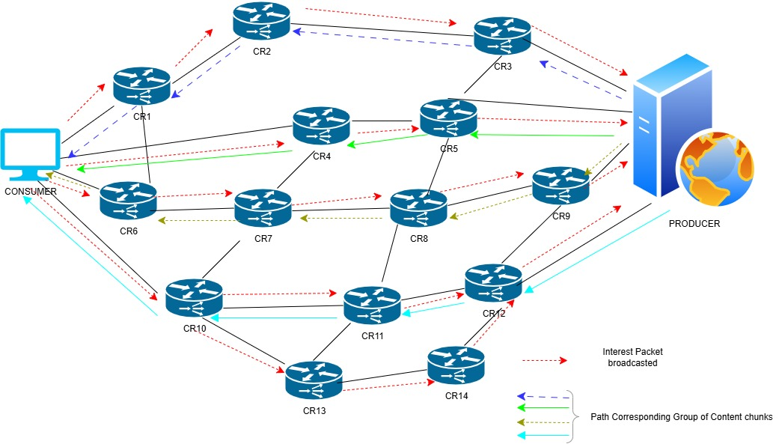

The Interest packet(IP) generated by the consumer is broadcast over the transmission network along several paths. The Content Routers (CR) receive an interest and register it at their PIT table. The CR checks whether the corresponding content chunk is held in the cache space of Content Store(CS). If the router lacks a PIT entry for the content, it checks the Forwarding Information Base (FIB) and forwards the Interest to upstream routers, identified by the longest prefix match. Interest forwarding continues hop-by-hop to the content producer.
For example, from the above figure. The IP generated by the consumer is broadcast along the different and distinct paths: {(CR1,CR2,CR3), (CR4,CR5), (CR6,CR7,CR8,CR9),
(CR10, CR11,CR12), (CR10, CR13, CR14, CR12)} registring the PIT entries to every routers
- The producer receives the IP for the particular time stamp, Say T=20 msec
- The arrival time should be less than the T.
- Count the number of requests that arrive at the Producer, which calculates the number of paths.s
- Calculate the forward delay for all path i=5
- If $t_{Consumer}^{send}=0$
i | $$t_{i}^{arr}$$ | $$d_{i}^{fwd}$$
1 | 3 | 3
2 | 2 | 2
3 | 4 | 4
4 | 5 | 5
5 | 6 | 6

- $d_{i}^{fwd}=t_{i}^{arr}-t_{Consumer}^{send}$

- Apply sorting in ascending order for $d_{i}^{fwd}$
- The producer fetches the corresponding content N and splits the content into K fixed-sized chunks K=21, fixed sized chunks each size 8 GB.
- Create the unique subset P_{i} for each distinct path.
path | chunks
1 | a_{1,}a₂,a₃
2 | a_{4,}a₅
3 | a_{6,}a₇,a_{8,}a_{9,}
4 | a_{10,}a_{11,}a₁₂,a_{13,}a₁₄
5 | a_{16,}a₁₇,a_{18,}a₁₉,a₂₀,a₂₁

- Check for each $d_{i}^{fwd}< {RTT}_{CR}$
- For path 1
- For each subset of chunk P₁, the Content router from 3 to 1.(Number of routers in path)
- For i= 3 to1
- To check the chunk a_{i} present at CR_{i}
- If not store at CS of CR_{i}
- Go to next hop
- Similarly for all paths
- Consumer receives the Chunks from multiple paths $R=\bigcup_{i}{P_{i}}$

1 | The consumer broadcasts Interests over all available paths.
2 | PIT entries are created at each hop for the requested name/segment.
3 | Initialize the parameter  Content name prefix N  Available paths i ={1,2,….,m}  S= chunk size
4 | Interest packets arrive via different paths, and the producer records all arrivals instead of discarding them.  Build the Interest arrival table for each path i entry $t_{i}^{arr}$  Count the number of entries k
 | For each path i
 | Store Arrival Time $t_{i}^{arr}$
Calculate Forward Delay of path i
$$d_{i}^{fwd}=t_{i}^{arr}-t_{Consumer}^{send}$$
5 | Calculate the goodput for each path i  $$g_{i}=\frac{S}{t_{i}^{arr}\left(k\right)-t_{i}^{arr}(k-1)}$$  $t_{i}^{arr}\left(k\right) is$arrival time of the current interest $k$on path $i$,  $t_{i}^{arr}(k-1)$ is the arrival time of the previous interest  The difference is the inter-arrival gap between successive Interests from path $i$.
Smoothed goodput
$$\overline{g_{i}}=\left(1-c\right)\overline{g_{i}}+cg_{i}$$
where $c$is the smoothing factor (c={0-1}=0.2)
- Based on the recorded timings, the producer identifies paths with higher ${\overset{ˉ}{g}}_{i}$as more efficient.
- The producer sends fewer chunks on low-goodput paths and more on high-goodput ones.

Split Content (N) into K chunks
$$N=\left\{n_{1},n_{2},…………,n_{k}\right\}$$

Create Subset $C_{i}⊂\left\{1,….K\right\}$
Multiple available path $i∈\{1,…m\}$
$$\left|C_{i}\right|=\left\lfloor \frac{w_{i}}{\sum_{j=1}^{m}{w_{j}}}.K\right\rfloor$$
$w_{i}=\frac{1}{d_{i}^{fwd}}$ or $w_{i}=\frac{\overline{g_{i}}}{r_{i}}$

 | Transmit chunks: $\{n_{k}:k∈C_{i}\}$for path i
 | Check for PIT entries
 | Store Chunks at CS
 | Consumer receives the Chunks from multiple paths $R=\bigcup_{i}{C_{i}}$

Path | Routers (h=1..3) delays (ms) | Total $d_{i}^{fwd}$ (ms)
Path 1 | [5, 6, 9] | 20
Path 2 | [8, 9, 12] | 29
Path 3 | [7, 10, 14] | 31

Path | $$t_{consumer}^{send}(ms)$$ | $t_{i}^{arr}$(ms) | $d_{i}^{fwd}$ (ms)
1 | 1000 | 1020 | 20
2 | 1000 | 1029 | 29
3 | 1000 | 1031 | 31

